To: John Doe, CEO

From: Wenting Zheng, Software Developer

Subject: Mixed Reality

Date: March 19, 2019

**Purpose**

The purpose of this report is to introduce Mixed Reality, a new technology and analyze its advantages and disadvantages

**Summary**

The entire report is divided into description, advantages, and disadvantages to introduce Mixed Reality and analyze its use in companies, especially the ones that require training.

**Description**

Mixed Reality, or Hybrid Reality, is blending the physical and digital world to form a visualization where the physical and virtual objects co-exist and interact. Two very similar and confusing concepts are VR and AR. Virtual Reality is a computer-generated virtual environment where users experience the digital world in a simulation (The Difference Between Virtual Reality, Augmented Reality And Mixed Reality, 2018). For example, playing video games or seeing a three-dimension photo through headsets. In an Augmented Reality, the user interacts with the physical objects and the virtual objects are “augmented” to the physical world, such as Google Cardboard. Mixed Reality, on the other hand, combines the interactions among human, computer, and the environment, which is a border definition. As seen in Figure 1, AR is closer to physical reality while VR is more relevant to digital reality(Bray, McCulloch, Schonning, & Zeller, 2018).

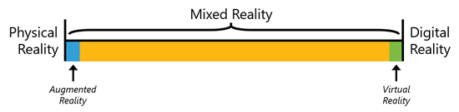

Figure 1 Mixed Reality Spectrum

Since MR immerses users in a physical virtual combined world, there are three main components in a MR System, the participant, the physical environmental sensor, and the virtual environment. As seen in Figure 2, the virtual environment contains intelligent agents, which are the autonomous entity which acts upon the provided information and environment to achieve certain goals(Ch’ng, E., Harrison, D., & Moore, S, 2017).

*Physical Features*

* The participants interact with the sensors to proform actions.
* The physical environmental sensors are the devices which collects physical world data and detect the paticipants’ motion. The physical world data will affect the virtual world.
* The virtual environment consists of the virtual objects which co-exist and able to interact with the real objects.
* The intelligent agents react according to the participants’ actions and both virtual and physical environment information.

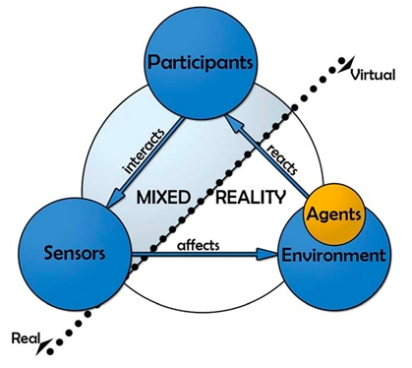

Figure 2 Mixed Reality Components

*Application*

Mixed Reality greatly changed the traditional approachs to art creation, learning, training, and working. MR allows the artists to perform externalized visual thinking and express their visual thoughts by easily manipulating digital objects with their hands (McKim, R. H., 1972, p. 40). The learning experience is enhanced by integrating simulation. The use of interactive learning and training provides the high-fidelity experience, which is really similar to real-life scenarios. Education is one of the major application of MR because of its interactive feature, which is key to improve the learning outcomes. MR is also widely used in healthcare because doctors are able to practice tasks with high risks or low possibilities of occurrence in a protected environment(Birt, J., Moore, E., & Cowling, M., 2017). Another excellent application of MR is remote working. This gives employees more flexibility in the workplace, physical locations, and communication. People have various workplace preference where they are more likely to achieve high work performance. For example, some employees prefer music and some prefer silence. MR allows them to individually modify their work environment without interupting others so that they can all be more productive. More flexible physical location and language are especially useful when teams need to collaborate globally. For example, the language will be a minor factor with the embedded real-time translation.

*Comparison with Other Techniques*

Table 1 shows several common training methods (Training Methods Experiential Learning and Technology - ppt download, 2009). A lecture is usually an oral presentation to convey particular information or subject.

A case study is when trainees learn how to make smart decisions based on some descriptive information about a situation. The panel discussion is gathering a selected group of people to discuss on a certain topic. The demonstration method requires the trainer to explain the concepts or tasks while showing how to do them. In a role play method, trainees are assigned to certain roles and pretend to be in a scenario, usually a working condition.

<https://slideplayer.com/slide/3917064/>

TODO

| Method | Pros | Cons |
| --- | --- | --- |
| Lecture | Good for high content if the presenter is good | Passive and not stimulating |
| Case study | Good focus and high involvement | Maybe dominated by a few participants |
| Panel discussion | High content and variety of perspectives | Low learner involvement |
| Demonstration | Opportunity to provide feedback | Does not involve everyone |
| Role play | Good practice for participants and involvement | Maybe dominated by a few participants |

Table 1: Compares the advantages and disadvantages of different training methods

Prepare a chart (choose an appropriate chart or table for your comparison) or a table that compares one aspect of your innovation (cost, availability, percentage of use, efficiency, time etc.) with the same aspect of what has been used in the past or what one or two other companies use. Remember, give a title and fully label your chart or table. Refer to the chart/table within the text.

**Advantages**

* MR is interactive
* MR can improve the training by simulating the real environment that feels real

**Disadvantages**

* MR is costly
* Simulation is not 100% accurate

**References**

Bray, B., McCulloch, J., Schonning, N., & Zeller, M. (2018, March). What is mixed reality? - Mixed Reality. Retrieved from <https://docs.microsoft.com/en-us/windows/mixed-reality/mixed-reality>

The Difference Between Virtual Reality, Augmented Reality And Mixed Reality. (2018, February 02). Retrieved from <https://www.forbes.com/sites/quora/2018/02/02/the-difference-between-virtual-reality-augmented-reality-and-mixed-reality/#3c2f25862d07>

Ch’ng, E., Harrison, D., & Moore, S. (2017). Shift-life interactive art: Mixed-reality artificial ecosystem simulation. Presence: Teleoperators and Virtual Environments, 26(2), 157-181. doi:10.1162/PRES_a_00291

Birt, J., Moore, E., & Cowling, M. (2017). Improving paramedic distance education through mobile mixed reality simulation. Australasian Journal of Educational Technology, 33(6). doi:10.14742/ajet.3596

Training Methods Experiential Learning and Technology - ppt download. (2009). Retrieved from <https://slideplayer.com/slide/3917064/>

McKim, R. H. (1972). Experiences in visual thinking (pp. 40-41). Boston: PWS Engineering.